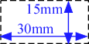
A Template for Preparing an Abstract for the Technical Poster Session of the International Forum by the NDF
- Title/Subtitle, 13pt
(1) The Template for MS-Word Users
- Author names, 11pt
Taro Hairo¹, Jiro Toridashi² and Hanako Kokusai^{1,2}
A blank space for ID number
¹Toranomon Univ., ²Decomissioning Research Institute
- Affiliations, 11pt
- Abstract, 10pt, Approx. 60 words

Abstract
Please summarize contents in your poster briefly.
- Make all section titles Bold, 10pt
1. Introduction
This is a template for authors registered for the Technical Poster Session of the 3rd International Forum.

2. Configuration of Page Layout
2-1. Length of the abstract
The abstract length is limited to 1 page of A4:210mm x 297mm. Please do not insert the page numbers in your abstract. The authors apply single column, and Top: 25mm, Bottom: 25mm, Left: 25mm, Right: 25mm as margins.
2-2. Font type
Century, Times New Roman and Symbol are recommended. The font should be embedded if you use other font types than these recommended.
2-3. Font sizes
1) Title/Subtitle: 13pt, 2) Author names: 11pt, 3) Affiliations: 11pt, 4) Abstract: 10pt, 5) Introduction to Conclusion: 10pt, 6) References: 9pt
2-4. Figures and Colors
The abstract may include tables, figures and captions. There are no restrictions on the use of colors in your abstract.
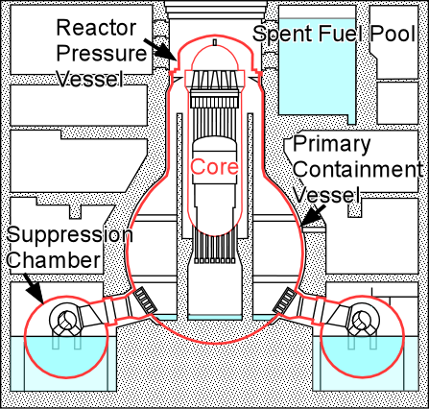
2-5. Points to consider when preparing PDF file
Figure 1. Cross section of BWR
The PDF file must not exceed 3MB. You are not allowed to compress/password protect the file or use any other security features.

3. Conclusion
We hope this template will be helpful for the authors who are preparing the abstract for the Technical Poster Session of the 2nd International Forum. Please submit your abstract to the Secretariat via our website. The abstracts will be distributed at the forum.
7) Caption, 10pt
7) Caption、表ラベル、図中の解説、グラフの軸ラベル等は英語, 10pt
7) Caption、表ラベル、図中の解説、グラフの軸ラベル等は英語, 10pt
6) References, 9pt
References
[1]
[2]
7) Caption、表ラベル、図中の解説、グラフの軸ラベル等は英語, 10pt
7) Caption、表ラベル、図中の解説、グラフの軸ラベル等は英語, 10pt
7) Caption、表ラベル、図中の解説、グラフの軸ラベル等は英語, 10pt
7) Caption、表ラベル、図中の解説、グラフの軸ラベル等は英語, 10pt

